Helpful Hints
to Make the Most of Your Time
in Denver

featuring
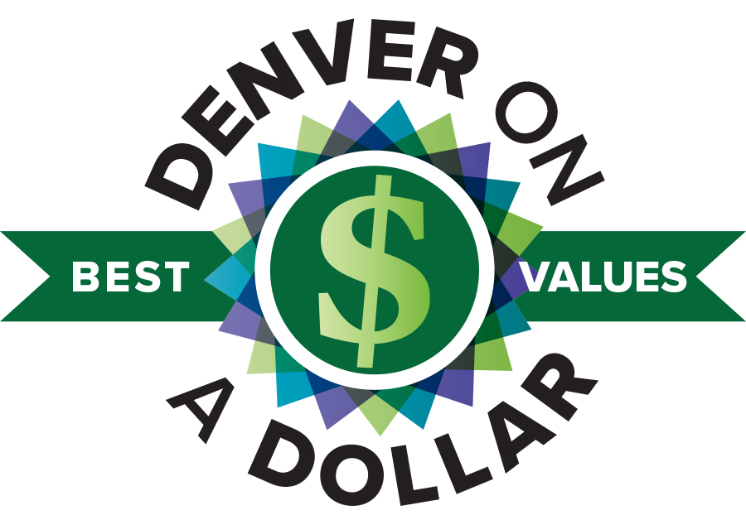

August 12 - 15, 2018
Sheraton Downtown Denver Hotel

TABLE OF CONTENTS
Transportation
Ride Sharing 3
Lyft / Uber / Cab 3
Super Shuttle 4
Public Transportation 4
Parking 5
Airline 6

dining
Restaurants 6

ADDITIONAL SAVINGS OPPORTUNITIES

Additional Savings Ideas 7

site seeing
Things to do around Denver 7

TRANSPORTATION
Flying into Denver? Here are some options for getting from the airport to the hotel.

RIDE SHARING
Use your favorite app to catch a ride. Lyft and UberX pick up at Passenger Pickup on Level 4, while UberBLACK picks up at Ground Transportation on Level 5, Island 2 or Island 5. Average cost from Denver International to Sheraton Denver Downtown is $35-$38.

Lyft will be offering discount fares to conference goers - be sure to check back in August to the conference to learn more. We also encourage you to use Groupon and online searches where you will often find coupon codes for using Lyft

LYFT - Requesting a Ride at DEN
Whether you’re taking off or landing, we’ve got you covered. For drop-offs, request a ride as usual. Here’s how Lyft pickups work at Denver International Airport.

Find Your Pickup Zone
After you land and grab your bags, open the app to find your pickup zone.
Head's up —you'll be directed to Arrivals (Level 6).

UBER
Request a Ride
Once you’re in the pickup zone, select your ride type and tap request.

Meet Your Driver
Look for your driver near the pickup zone you selected.

General Tips for how to get picked up with Uber at DEN Airport

Request when you’re ready to walk outside.
  - And choose a ride option that suits your group size and luggage storage needs.

Exit on the right level.

Riders requesting uberX, uberXL, or UberSELECT can meet their driver upstairs on level

Riders requesting UberBLACK, or UberSUV can meet their driver on level 5. Passengers with accessibility needs may be picked up in the designated ADA access zone on the arrivals level.

Meet your driver curbside.
- There are two sides to the DEN terminal (East and West), so be sure to select the appropriate side after you hit “Request”.
- If you are unsure of your terminal, check the signs posted outside.
- If you need to confirm your pickup location, contact your driver through the app.

CABS
The average cost of a cab ride from the Airport to the hotel is $51 for the first traveler, $1 for each additional person sharing the cab.

SUPER SHUTTLE
DISCOUNT CODE: 2367S
DISCOUNT VALID DATES: August 6th through 19th
LINK: http://supershuttle.com/default.aspx?GC_2375
WHERE TO ENTER YOUR CODE: To use your code simply enter it in the “DISCOUNT CODE” box on the first page of the website when making your reservations at: http://www.supershuttle.com
DISCOUNT: Your discount gives you $2.00 off one-way and $4.00 off round trip SuperShuttle shared ride reservations made online. The discount does not apply to ExecuCar private vehicles, nor to the exclusive/non-stop vans (which are already discounted).
RESERVATIONS: For special reservation questions call 1-800 BLUE VAN (800-258-3826) or customer service, available 24/7. Please note that if you call in your reservation instead of booking and paying online with your discount code, then your discount is not valid, and a $3 call center fee applies.

ARRIVAL PROCEDURES:
SuperShuttle: After collecting luggage, customer must proceed to the SuperShuttle ticket counter to speak with a uniformed Customer Service Representative. The ticket counter is located between the women’s restroom and the ground transportation booth on the southwest side of the terminal. The ticket counter is staffed from 7:00 AM to 9:30 PM daily. A CSR will direct customer to the appropriate shuttle loading area on the transportation island. After hours, customer may use the courtesy phone located at the ticket counter to connect directly to dispatch for further assistance.

PUBLIC TRANSPORTATION

AIRPORT RAIL TO DOWNTOWN/DOWNTOWN TO AIRPORT
At a cost of only $9 each way (discounted for seniors and individuals with disabilities), travelers can now take the airport rail from DEN to Denver Union Station and vice versa. The 23-mile ride takes approximately 37 minutes.

When you exit the aircraft, follow signs for baggage claim or the transit center. You will need to board the airport tram to get to Jeppesen Terminal where baggage claim and ground transportation is located.
Domestic arrivals are located in the center of the main terminal on level 5. International arrival is located at the north end of the terminal. Baggage claim is also located on level 5.

To get to Denver Airport Station, follow signs to the Transit Center and proceed to the south exit on level 5 (look for the large American flag), exit the terminal through the sliding glass doors and take the escalator located in the center of the plaza down to level 1. At the Airport, the location is right by the new Westin Denver International Airport Hotel. Tickets can be purchased on rail line platforms at ticket vending machines, in the DUS underground bus concourse, at official Denver Tourist Information Centers or at any RTD sales outlet.

The A Line, which opened on April 22, 2016, whisks travelers to the heart of downtown, specifically the recently restored Union Station, which is the city's new transportation hub and "living room," thanks to its plush surroundings. From Union Station, travelers can access additional local and regional transportation services, such as light rail, regional and local buses, Amtrak rail service, taxis, and the free 16th Street Mall shuttle (MallRide) and free downtown MetroRide buses that provides access to most downtown hotels. Union Station itself is a beautiful 1914 Beaux-Arts building and the location of hip, locally owned restaurants, bars, shops and a boutique hotel.

DAILY SCHEDULE FROM UNION STATION
3:15 a.m. - 4:15 a.m. - every 30 minutes
4:15 a.m. - 6:30 p.m. - every 15 minutes
6:30 p.m. - 12:30 a.m. (1 a.m. Fri/Sat) - every 30 minutes
*Last train leaves Denver International Airport at 1:26 a.m. (1:56 a.m. Fri/Sat)

The free 16th Street MallRide hybrid shuttle buses travel up and down the 16th Street Mall between DUS at Wynkoop Street and the Broadway & Colfax stop. The MallRide stops on every corner as often as every 90 seconds and runs from 5:00 a.m. to 1:20 a.m. on weekdays, 5:30 a.m. to 1:20 a.m. on Saturdays and 6:30 a.m. to 1:20 a.m. on Sundays.

TRANSPORTATION OPTIONS FROM UNION STATION TO YOUR HOTEL
Download the Denver Union Station Arrival Guide here. Free 16th Street Mall Ride Free hybrid shuttle buses travel up and down the 16th Street Mall between DUS at Wynkoop Street and the Broadway & Colfax stop. The MallRide stops on every corner as often as every 90 seconds and runs from 5:00 a.m. to 1:20 a.m. on weekdays, 5:30 a.m. to 1:20 a.m. on Saturdays and 6:30 a.m. to 1:20 a.m. on Sundays.

PARKING

Driving into town or renting a car?

Hotel Parking
Self-Parking
0-1 hour: $12
Each additional hour: $6
Maximum daily rate: $40
Mon - Fri 5pm-4am: $12
Weekend rate (day parking only): $12
Overnight rate: $40
Oversized vehicles: $55

Valet Parking
0-3 hours: $29
3-8 hours: $35
8+ hours: $42
Overnight: $49
Oversized: $55

Off-Site parking close to the hotel
$16.00 Day
1441 Court Pl Parking- 1441 Court Pl, Denver, CO 80202
Time Parking $16 Day- 1439 Court Pl, Denver, CO 80202
1411 Court Pl Parking-1411 Court Pl, Denver, CO 80202

AIRFARE

United Airlines is offering a group discount to Pioneer Network conference attendees. Here’s what you need to know.

Pioneer Network (2018)
Z Code: ZEZG
Agreement Code: 342222

Enter location: Denver, CO US
Valid Travel Dates: 8/9/2018 - 8/18/2018

Reservation Information:
- US 50 States & Canada Customers: call your professional travel agency, book online via united.com or call United reservation Desk at 800-426-1122 and provide the Z Code ZEZG and Agreement Code 342222
- Passengers outside the US 50 States & Canada: call your professional travel agency, book online via united.com or email groupmeeting@united.com and provide your preferred itinerary, agreement code and meeting Z code. Please allow 24 hours for email requests to be processed.
Travel agency bookings: To avoid debit memos and ensure tracking for United Meetings Rewards, the four-digit Z-code must appear in the Tour Code box. Note: Do not add letters “IT” in the Tour Code box or any other information in the Tour Code box other than the four-digit Z-code.

DINING

Looking for some place to eat while in Denver? The 16th Street Mall offers every type of fare from fast food or casual fare - if you’re looking to experience Denver on a Dollar - to fine dining. We also hear that during the summer, you will find a selection of Food Trucks parked along the Mall selling their wares!

To see everything downtown Denver has to offer, check out the Interactive Dining Guide. The Sheraton Denver Downtown is located at the bottom right hand corner of the map in the guide and anything on the 16th Street Mall is walking distance or accessible using the free bus that runs continuously on the Mall.

ADDITIONAL OPPORTUNITIES TO SAVE
Going Green Hotel Incentive
Conserving water, energy and other resources is rewarding for you and great for the environment. Enjoy a $5 voucher at participating food and beverage outlets or 500 Starpoints® awarded at check-out for each night you decline housekeeping (except day of departure). It feels good to conserve. Make A Green Choice.
To participate in the Make a Green Choice program, please let the hotel know at check-in or look for the doorhanger in your guestroom.

Looking for some snacks for your room? Each guest room is equipped with a refrigerator. Check out the Grocery and Drug Stores along the 16th Street mall to get what you need to stock it with the things you like to eat and drink!

SITE-SEEING

Things to do in Denver

Looking for things to do in and around Denver? Check out “DENVER: The Mile High City” website and look under “Things to Do”

Museum’s located within walking distance of the Downtown Denver Sheraton Hotel
Denver Mint
The Money Museum at the Federal Reserve Bank of Kansas
Denver Art Museum
Molly Brown House Museum
Kirkland Museum of Fine & Decorative Art
Denver Firefighters Museum

More things to do around Denver…

Site-seeing tours
https://www.denver.org/listing/aspire-tours/13975/https://www.denverfreewalkingtours.com/free-tourhttps://boulderbiketours.com/product/mountain-bike-tour/https://www.denver.org/things-to-do/itineraries/free-denver-tours/

Day Trips Around Denver
- https://www.denver.org/things-to-do/itineraries/off-beat-tours/

Want to See Denver while riding a Segway?
- https://www.coloradosegwaytours.com/

