The Coronavirus:

A fleeting illness but life goes on ...



Written by Jean-Louis & Roger, residents, and Marie, psychologist

EHPAD Mathilde Laurent

Villeneuve les Maguelone, France



What is Coronavirus?

It is a new form of flu, transient but very contagious !

The symptoms are mainly fever, cough, sore throat and fatigue.

If you experience these symptoms, it is important to report them to a nurse or caregiver as soon as possible.



How is coronavirus transmitted?

This virus is mainly transmitted by physical contact, saliva or respiratory droplets.

It affects people of all ages, but older people are more at risk for complications.

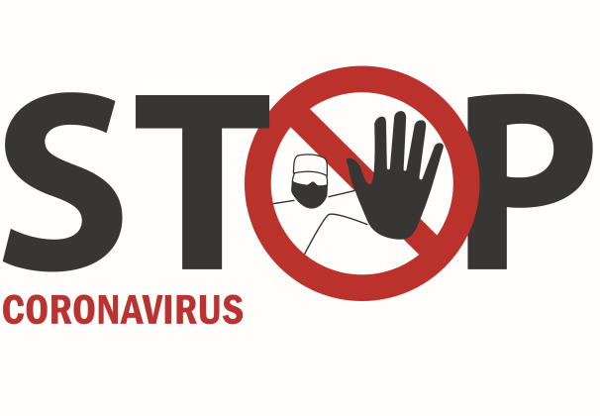

Visits and outings are temporarily stopped, to avoid spreading the virus.

Everyone must follow the guidelines to avoid falling ill.

Management is taking all necessary precautions to keep us safe.

Thanks for your understanding.

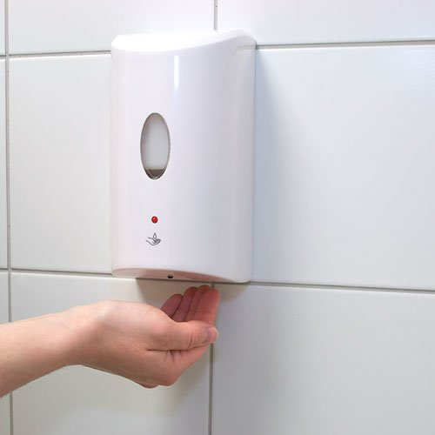



What are tips to avoid catching it?

It is important to wash your hands thoroughly with soap or hand sanitizer. It is also important to properly dispose of your tissues and not leave them lying around. Avoid leaving your room as much as possible.

For everyone's health, it is important to follow these tips.



All the staff do their best to care for you during this period. Visits are restricted, but you can make video calls to your loved ones. Do not hesitate to ask someone to help set up a call for you. Your family is well informed of the situation.

We hope to have answered your questions.